SCREENSHOTS OF DASHBOARDS

AWS LOGIN SCREEN WITH USERNAME

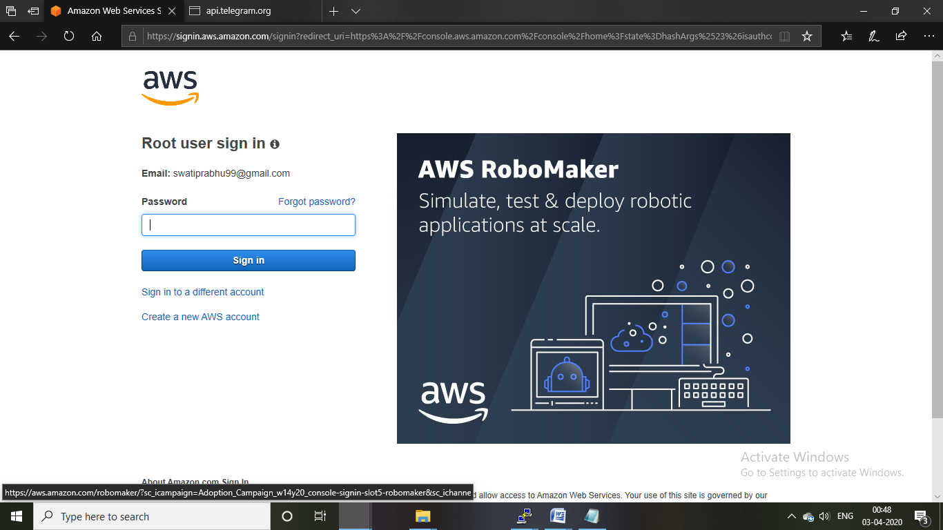

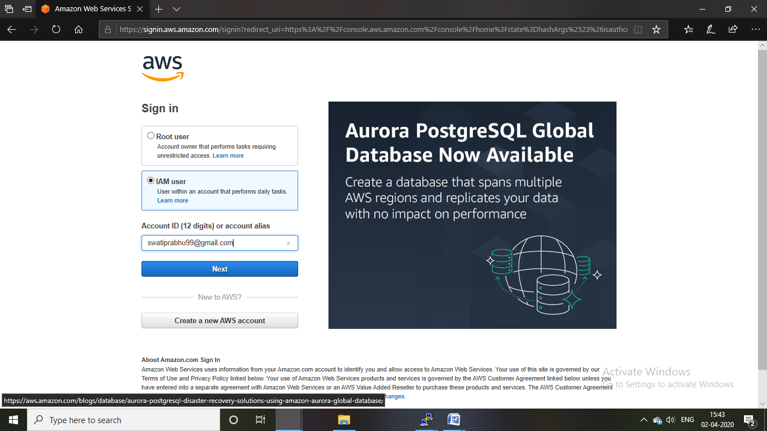

EC2 DASHBOARD

Had already created an instance before taking ss hence running instance is 1

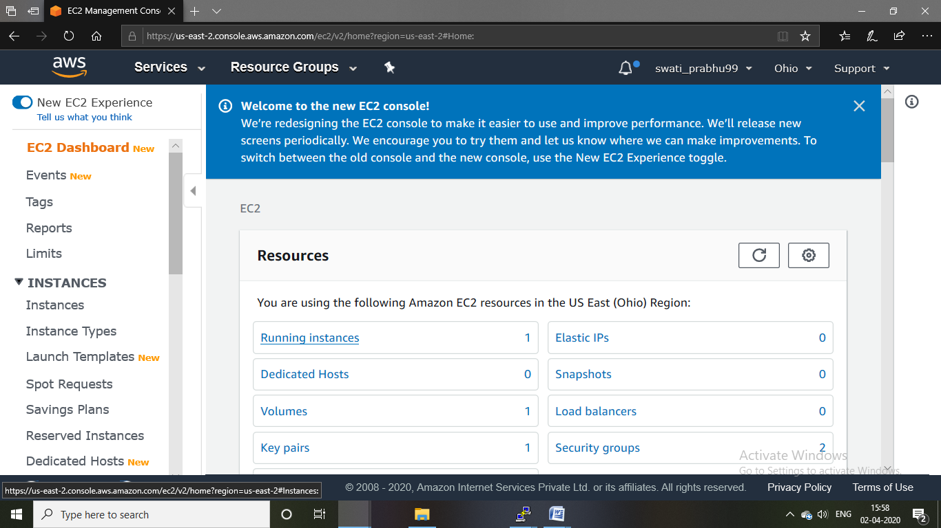

S3 DASHBOARD

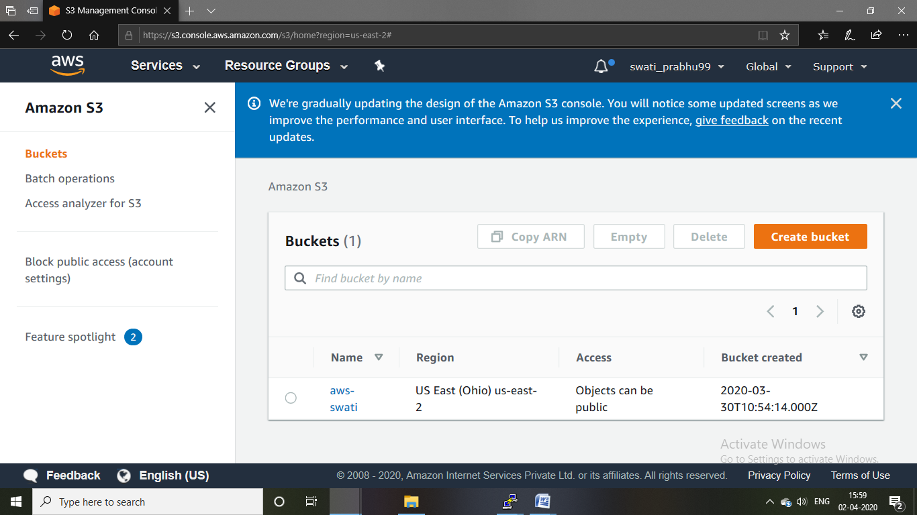

REKOGNITION DASHBOARD

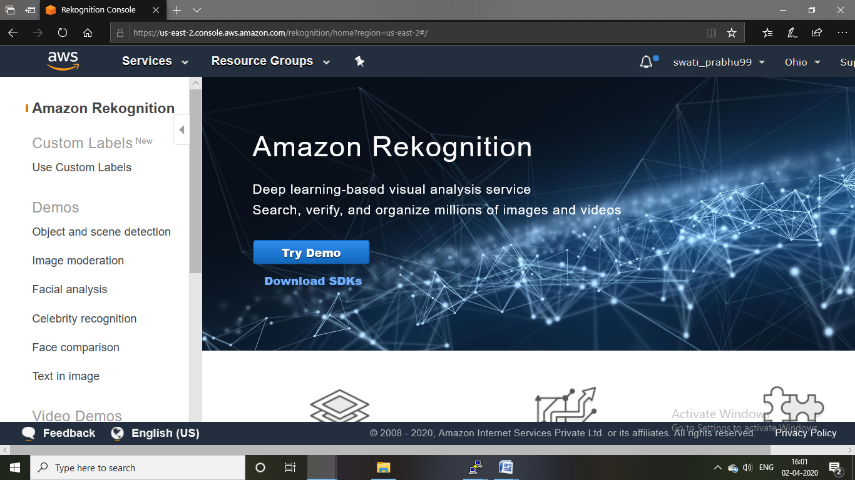

SCREENSHOTS NEEDED FOR EC2

CHOOSING AN AMI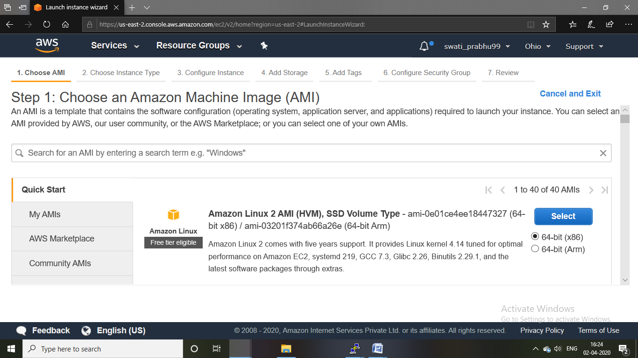

CHOOSING AN INSTANCE TYPE

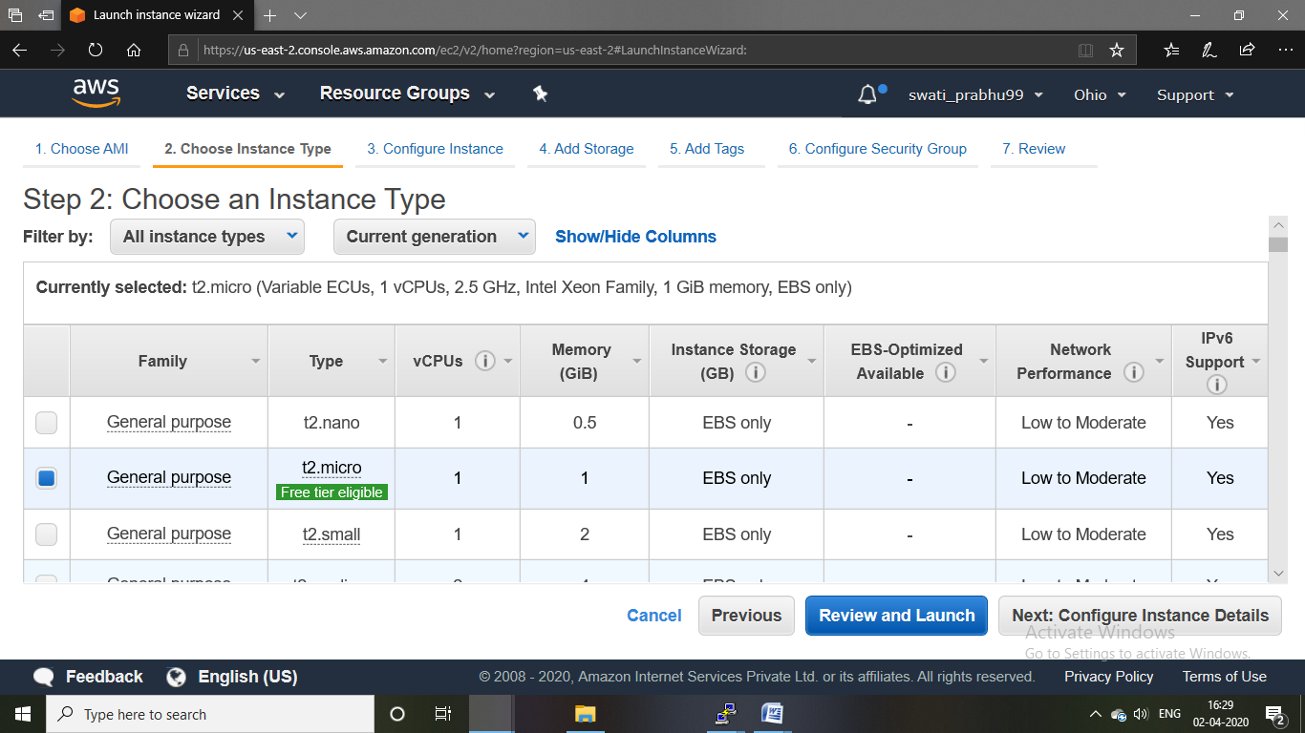

ADDING STORAGE

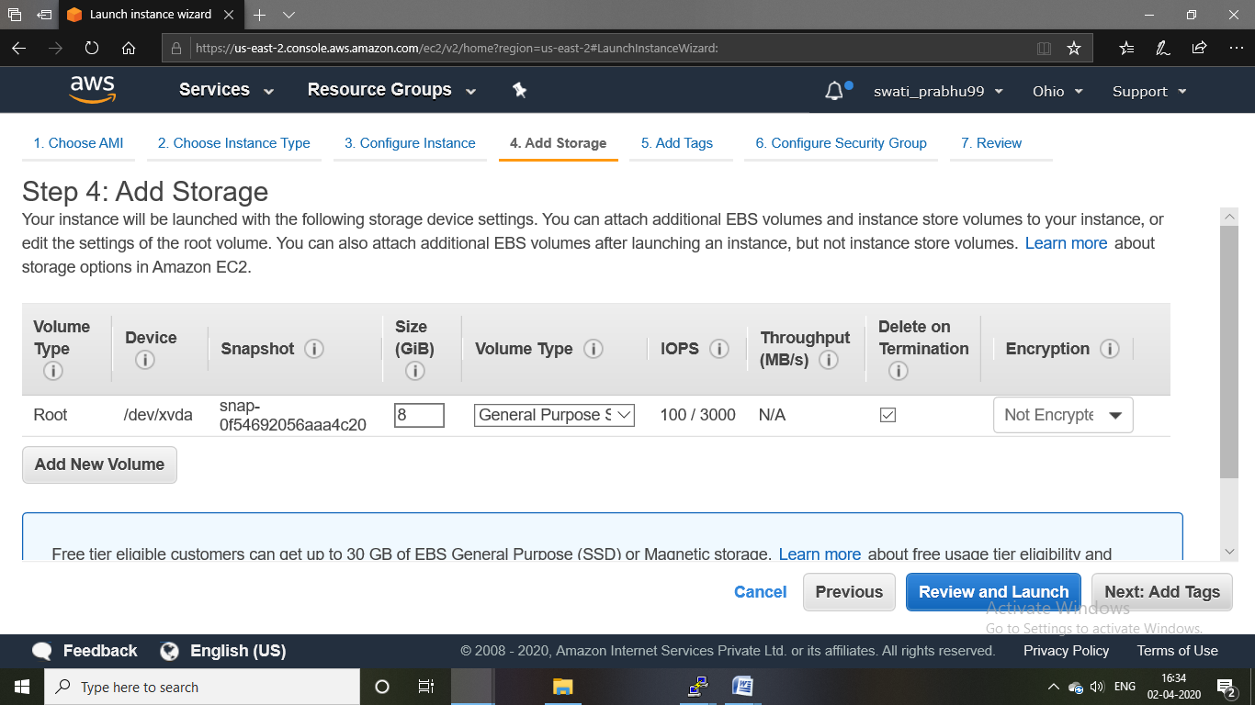

CONFIGURING SECURITY GROUP

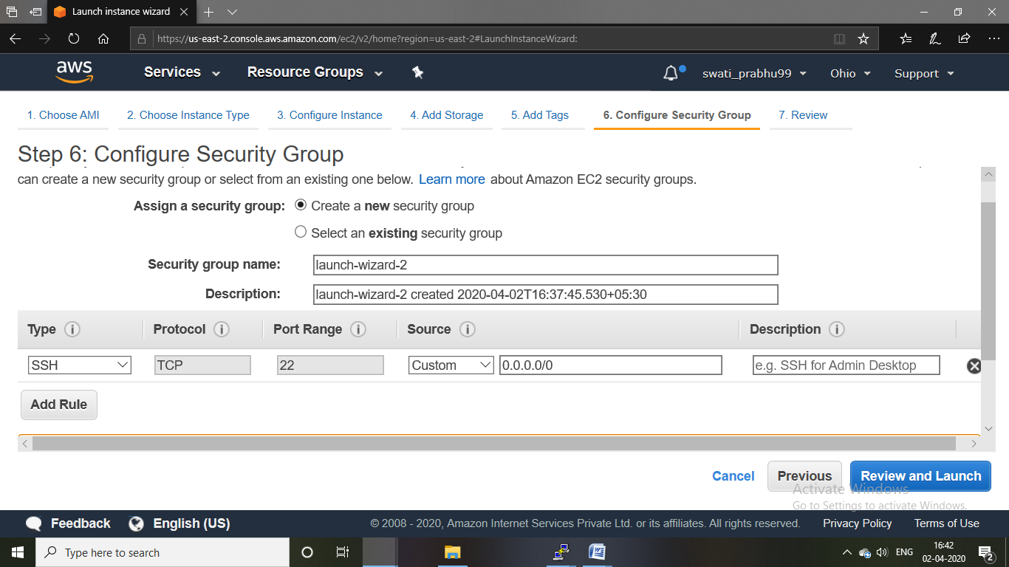

KEY PAIR DOWNLOAD

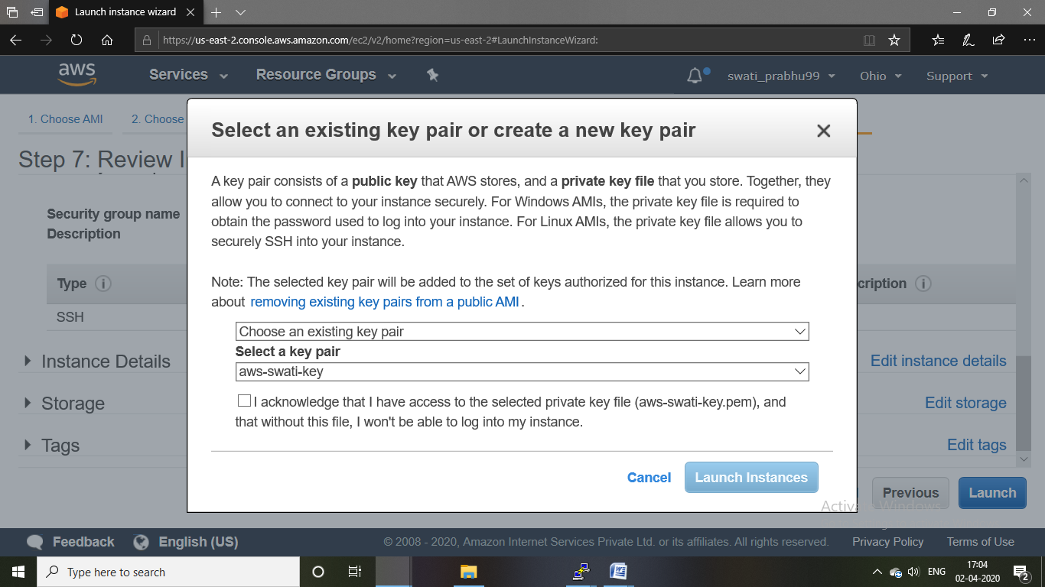

PUTTY GEN CONVERSION FROM PEM TO PPK

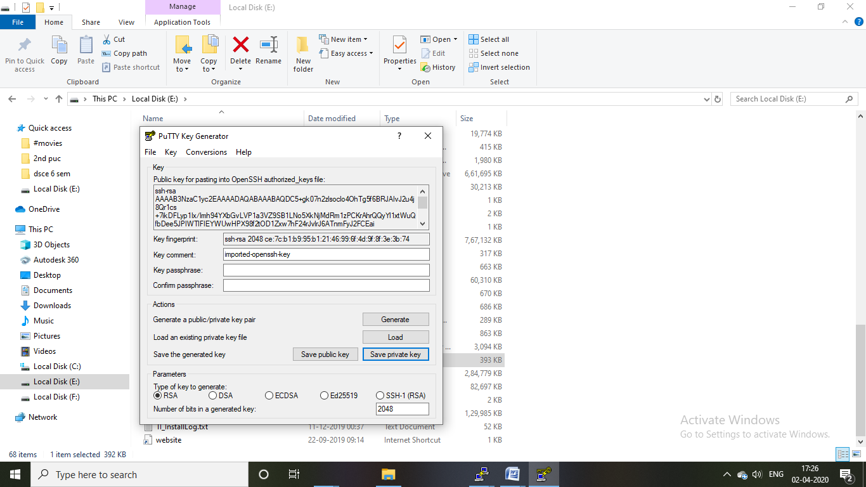

LOGGED IN EC2 BLACK SCREEN

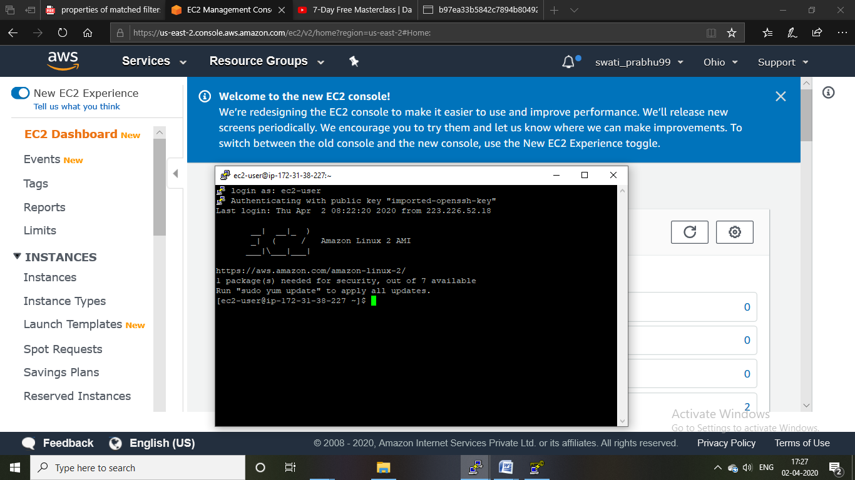

SCREENSHOTS NEEDED FOR S3

CREATE A BUCKET

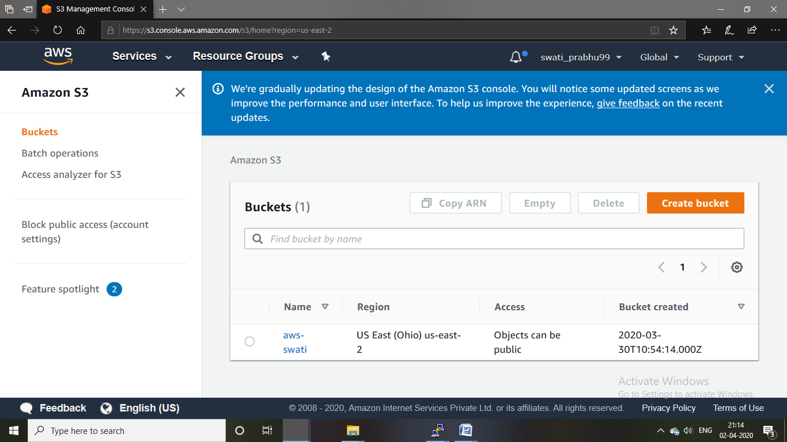

UPLOADING AN OBJECT

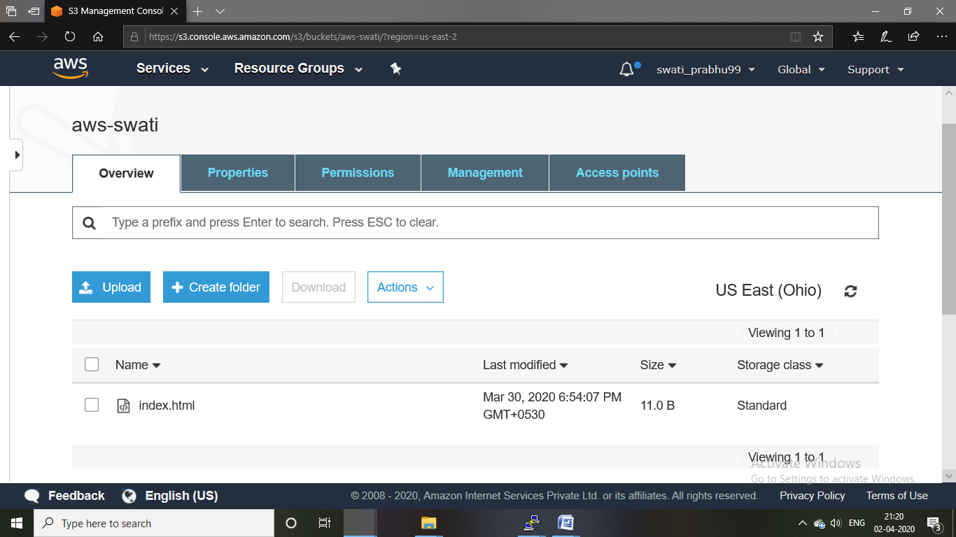

ENABLING STATIC WEBSITE

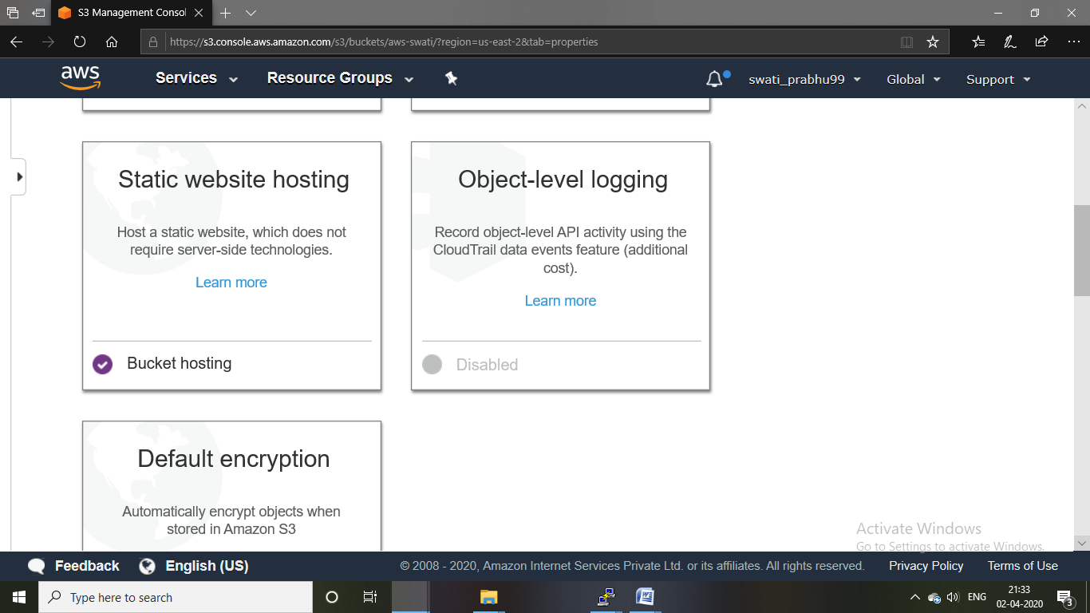

MAKING THE OBJECT PUBLIC

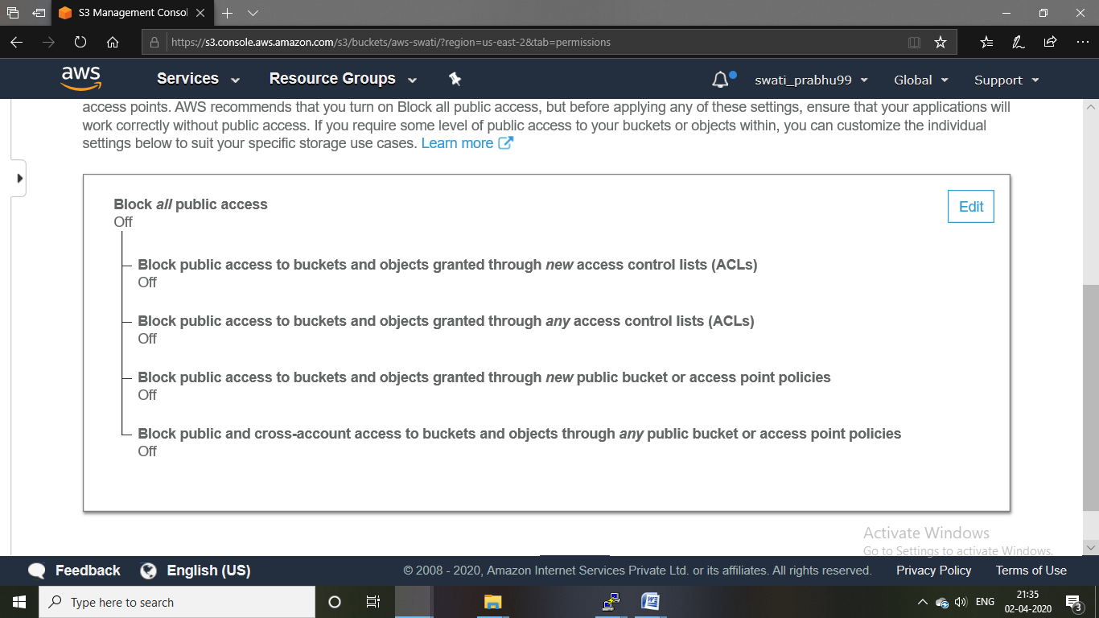

CHECKING S3 LINK ON BROWSER

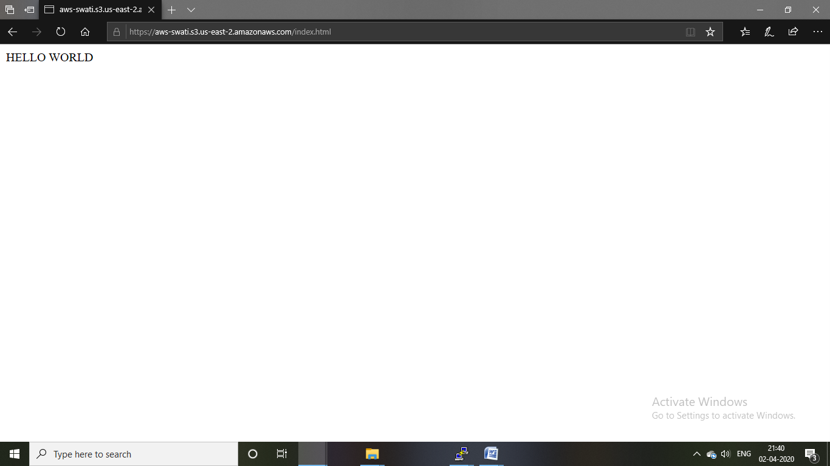

SCREENSHOTS NEEDED FOR REKOGNITION

FACE DETECT

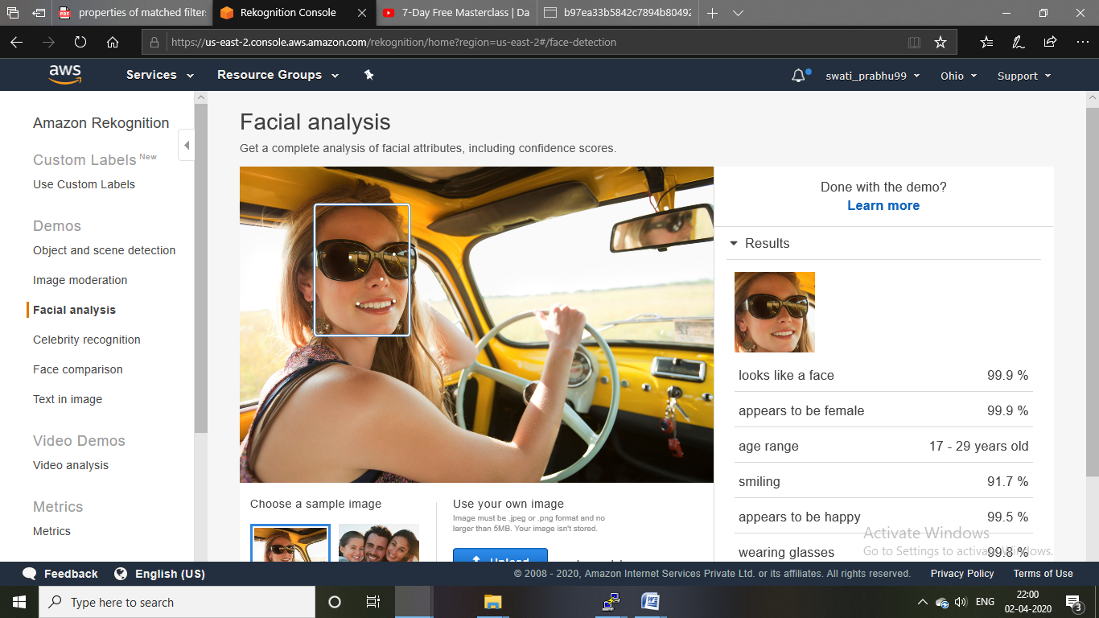

FACE COMPARISON

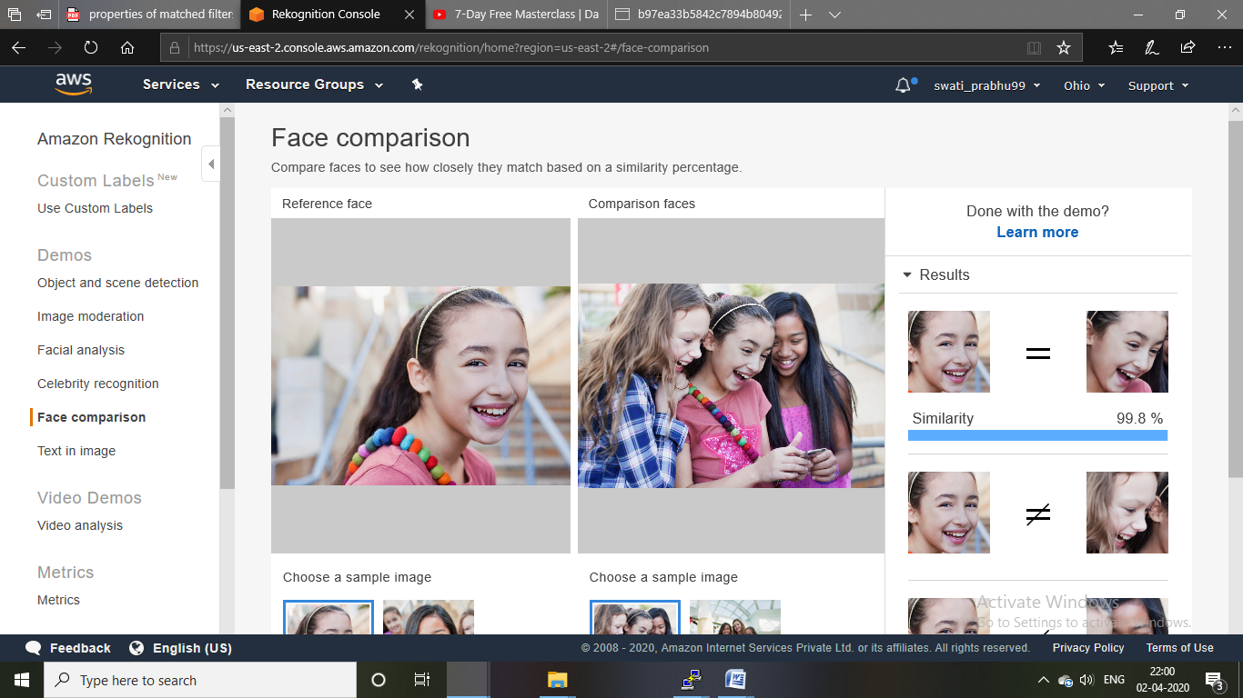

CELEBRITY RECOGNITION

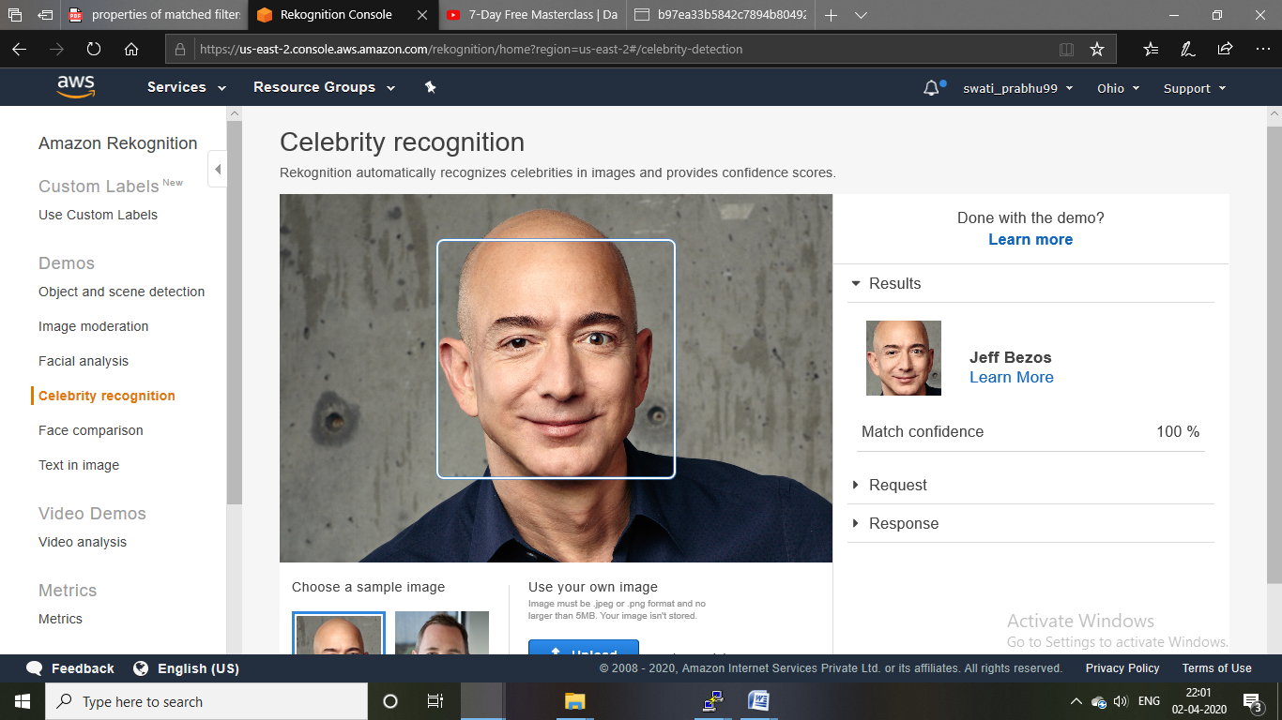

TEXT IN IMAGE

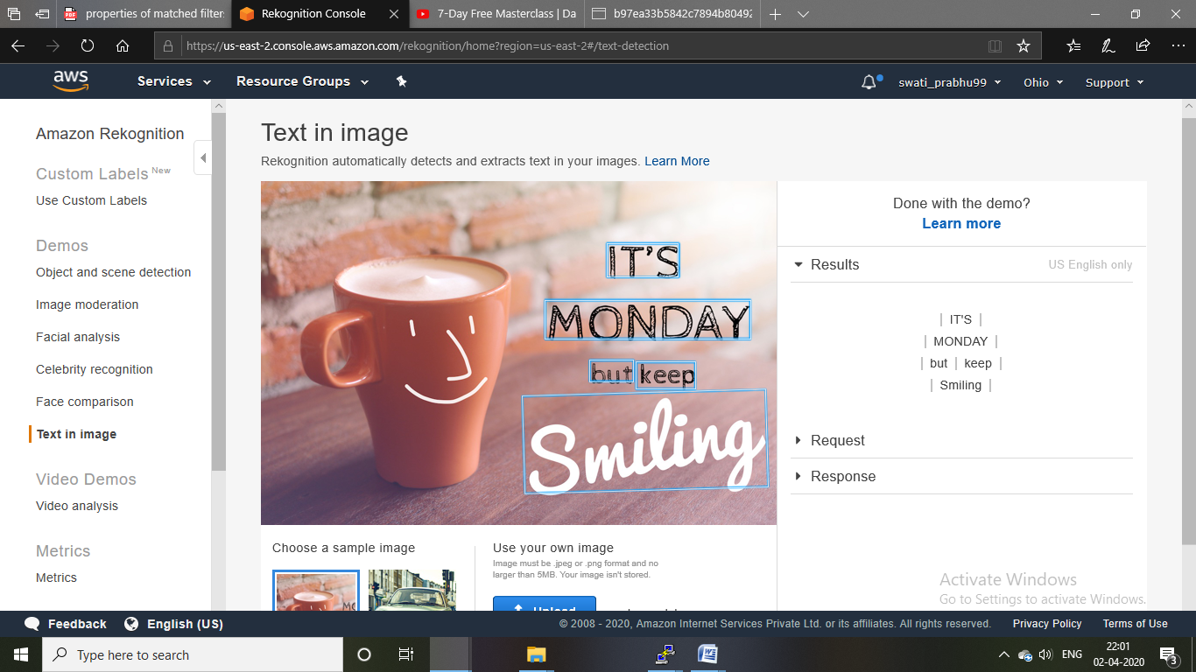

SCREENSHOTS NEEDED FOR EC2 AND S3

INSTALLING AWS.SDK

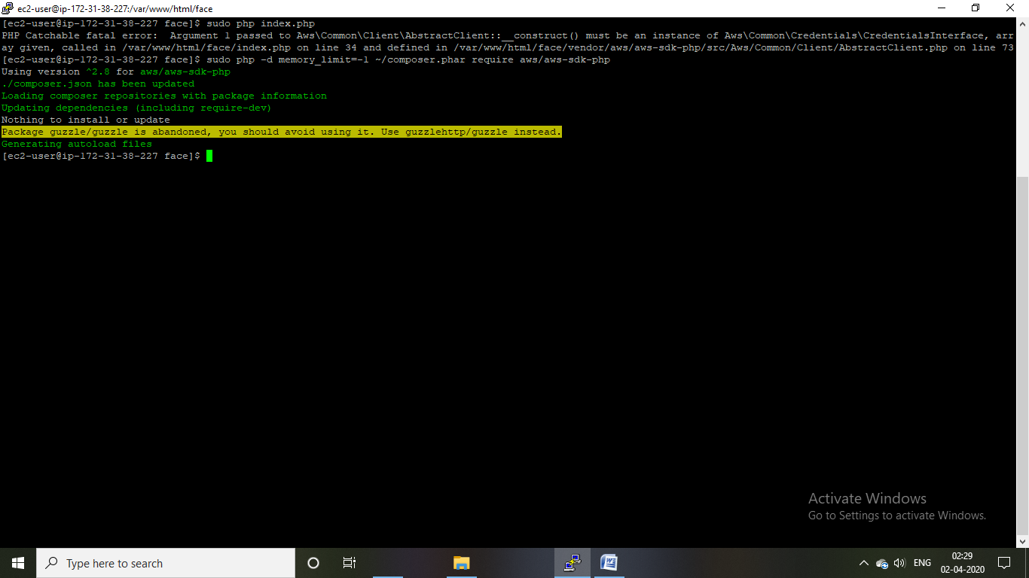

INSTALLING PHP

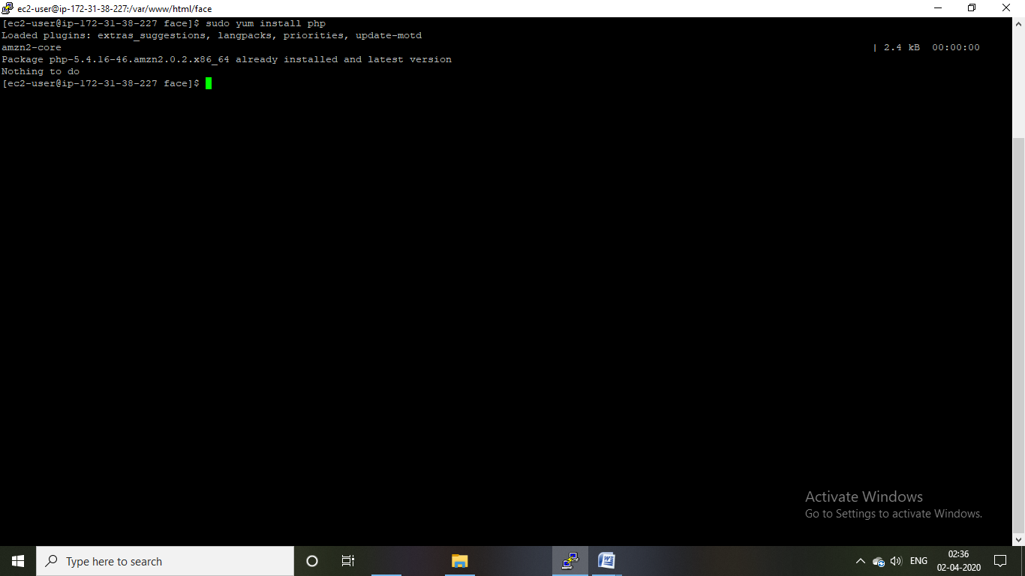

INDEX.PHP FILE CODE

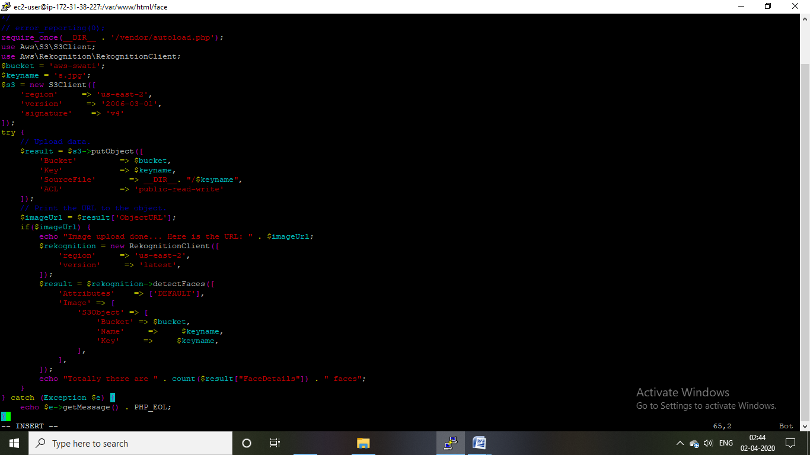

UPLOAD SUCCESS SCREENSHOT

